Willis Allstead

9/23/18

CPE 400

HW1

Part 1

**1.**

**a)**

a<->b is 1Mb/s

b<->c is 2 Mb/s

transmission delay = (packet length)/(link bandwidth)

transmission delay over link A – B = (1,000*8)/(1,000,000) = 0.008s

transmission delay over link B – C = (1,000*8)/(2,000,000) = 0.004s

**b)**

nodal processing delay at B = 1ms = 0.001s

queuing delay at B = 3ms = 0.003s

propagation delay at B = 0

Total delay from A to C = 0.008s + = 0.004s + 0.003s + 0.001s = 0.016s

Part 2

**2.**

**a)** HTTP version 1.1 is running

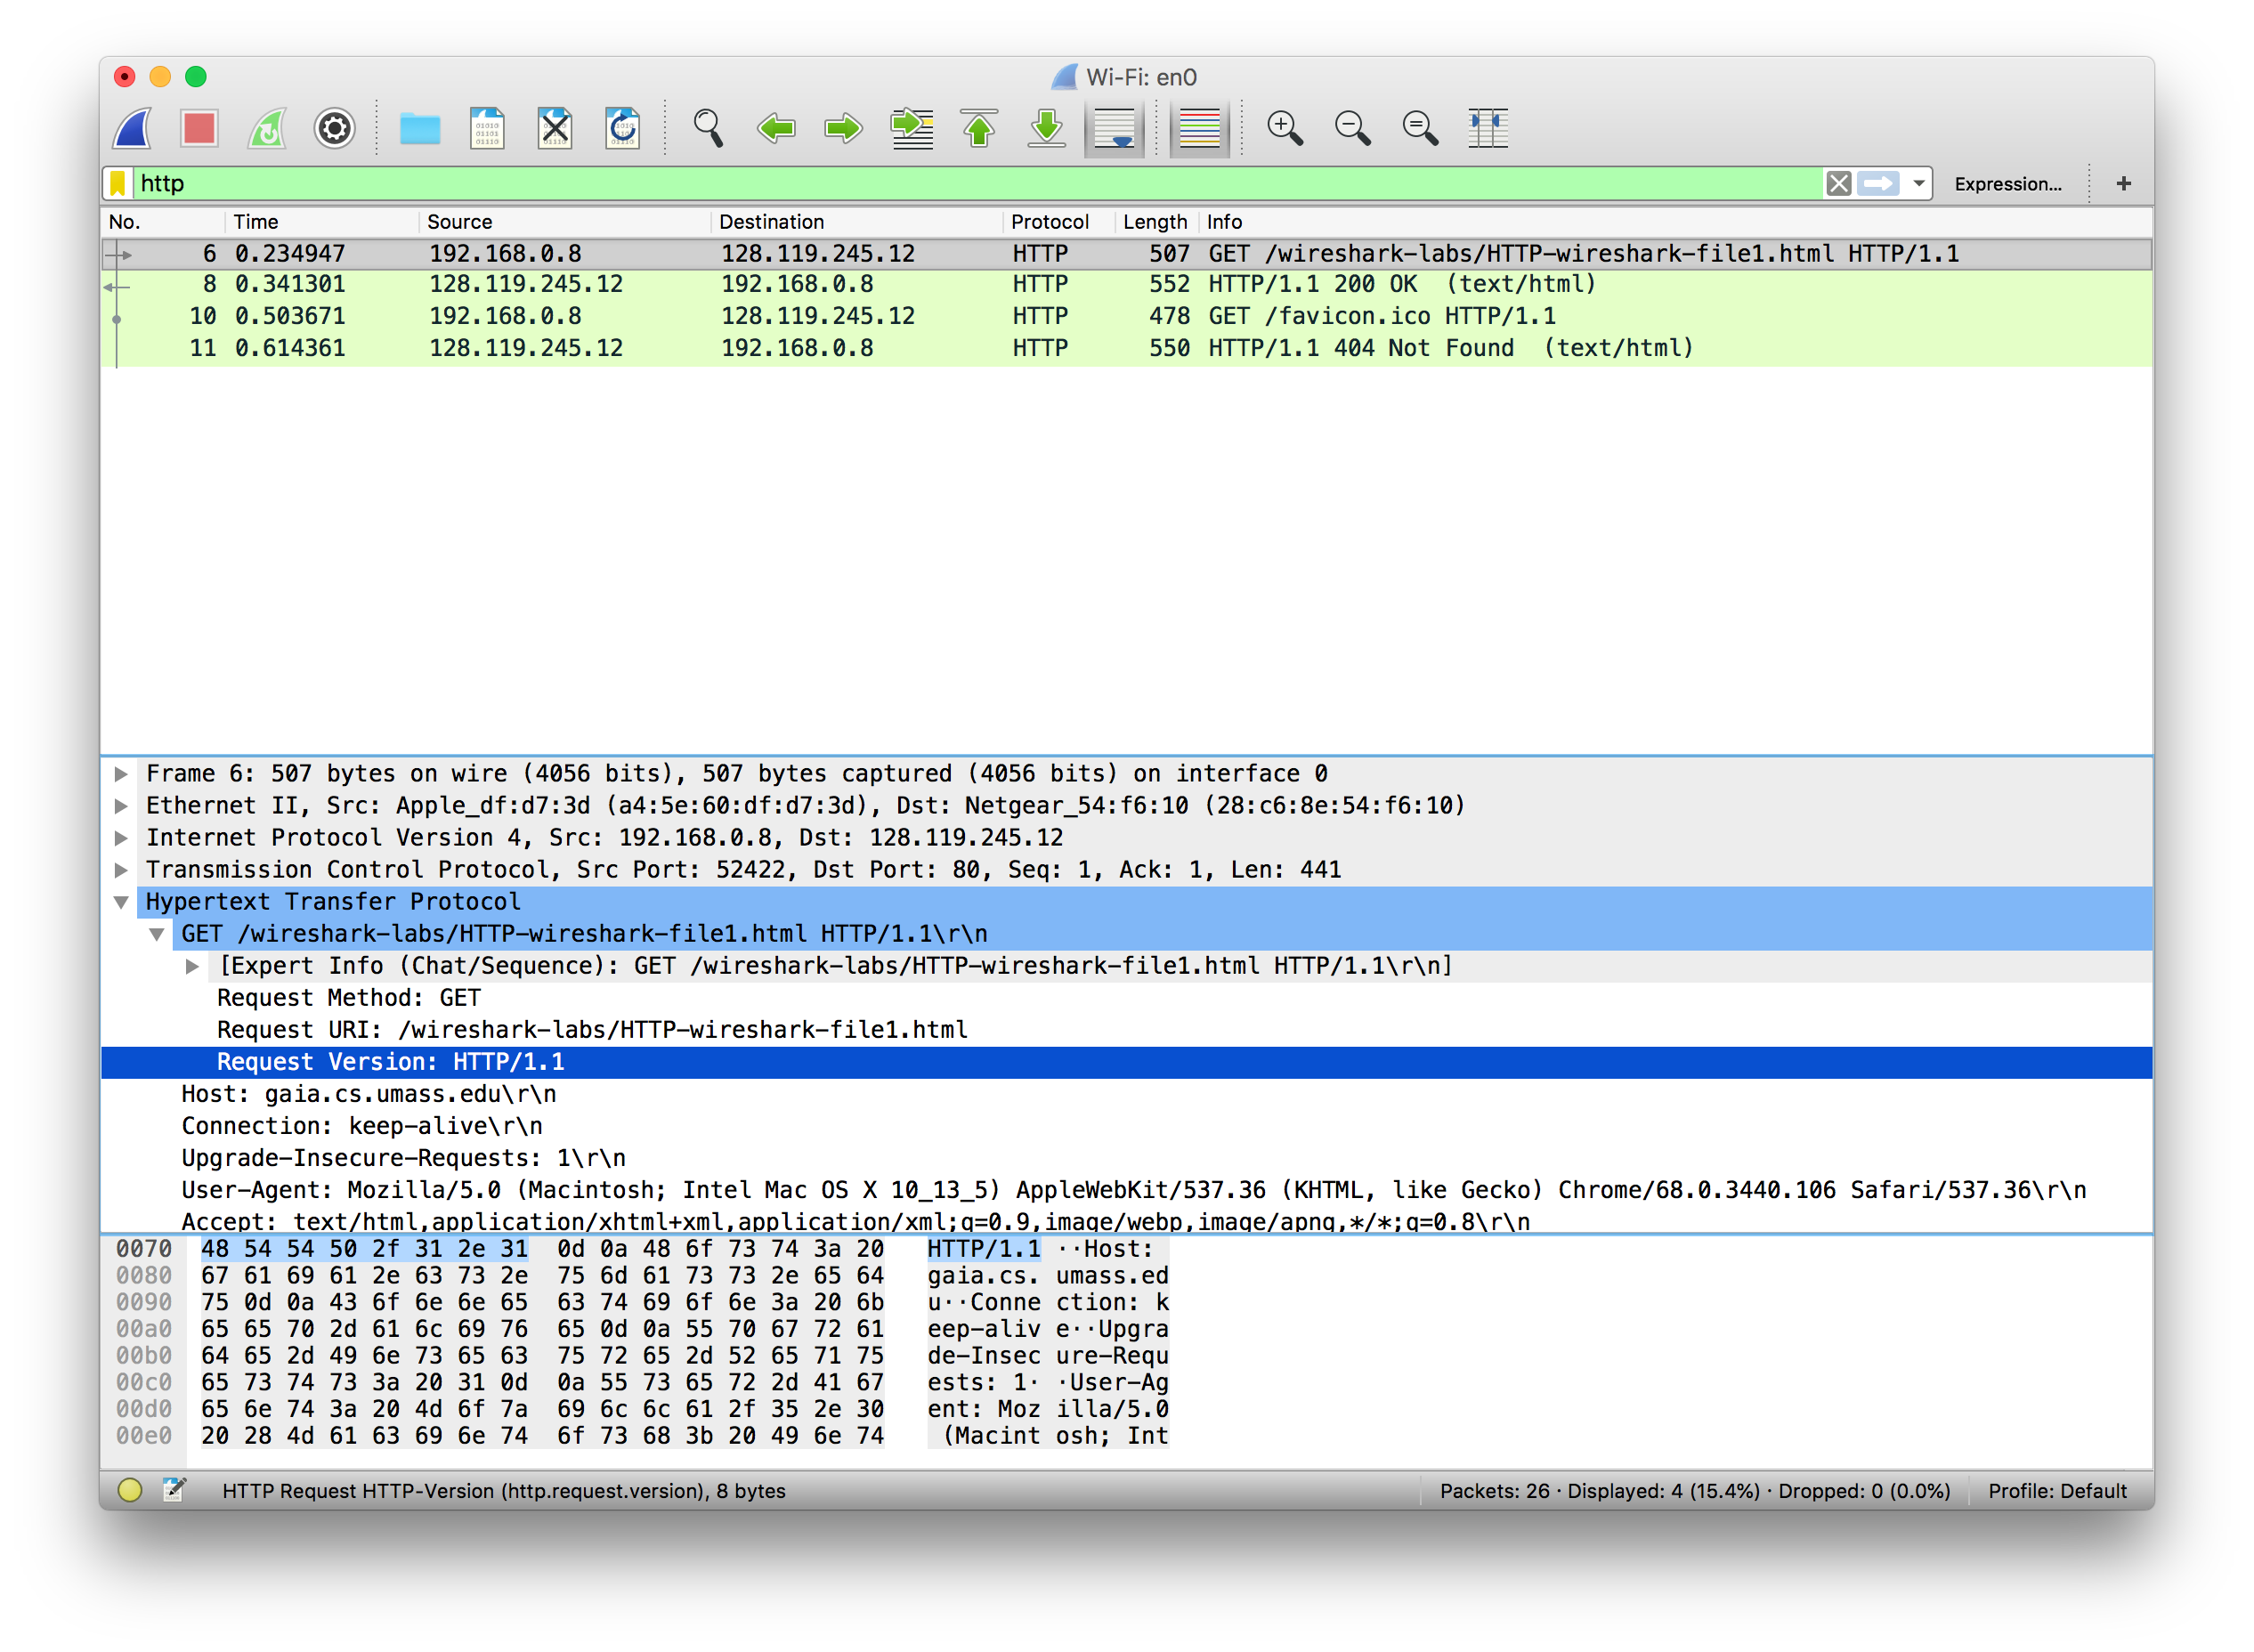

**b)** My computer’s IP address:192.168.0.8, gaia.cs.umass.edu server IP address: 128.119.245.12

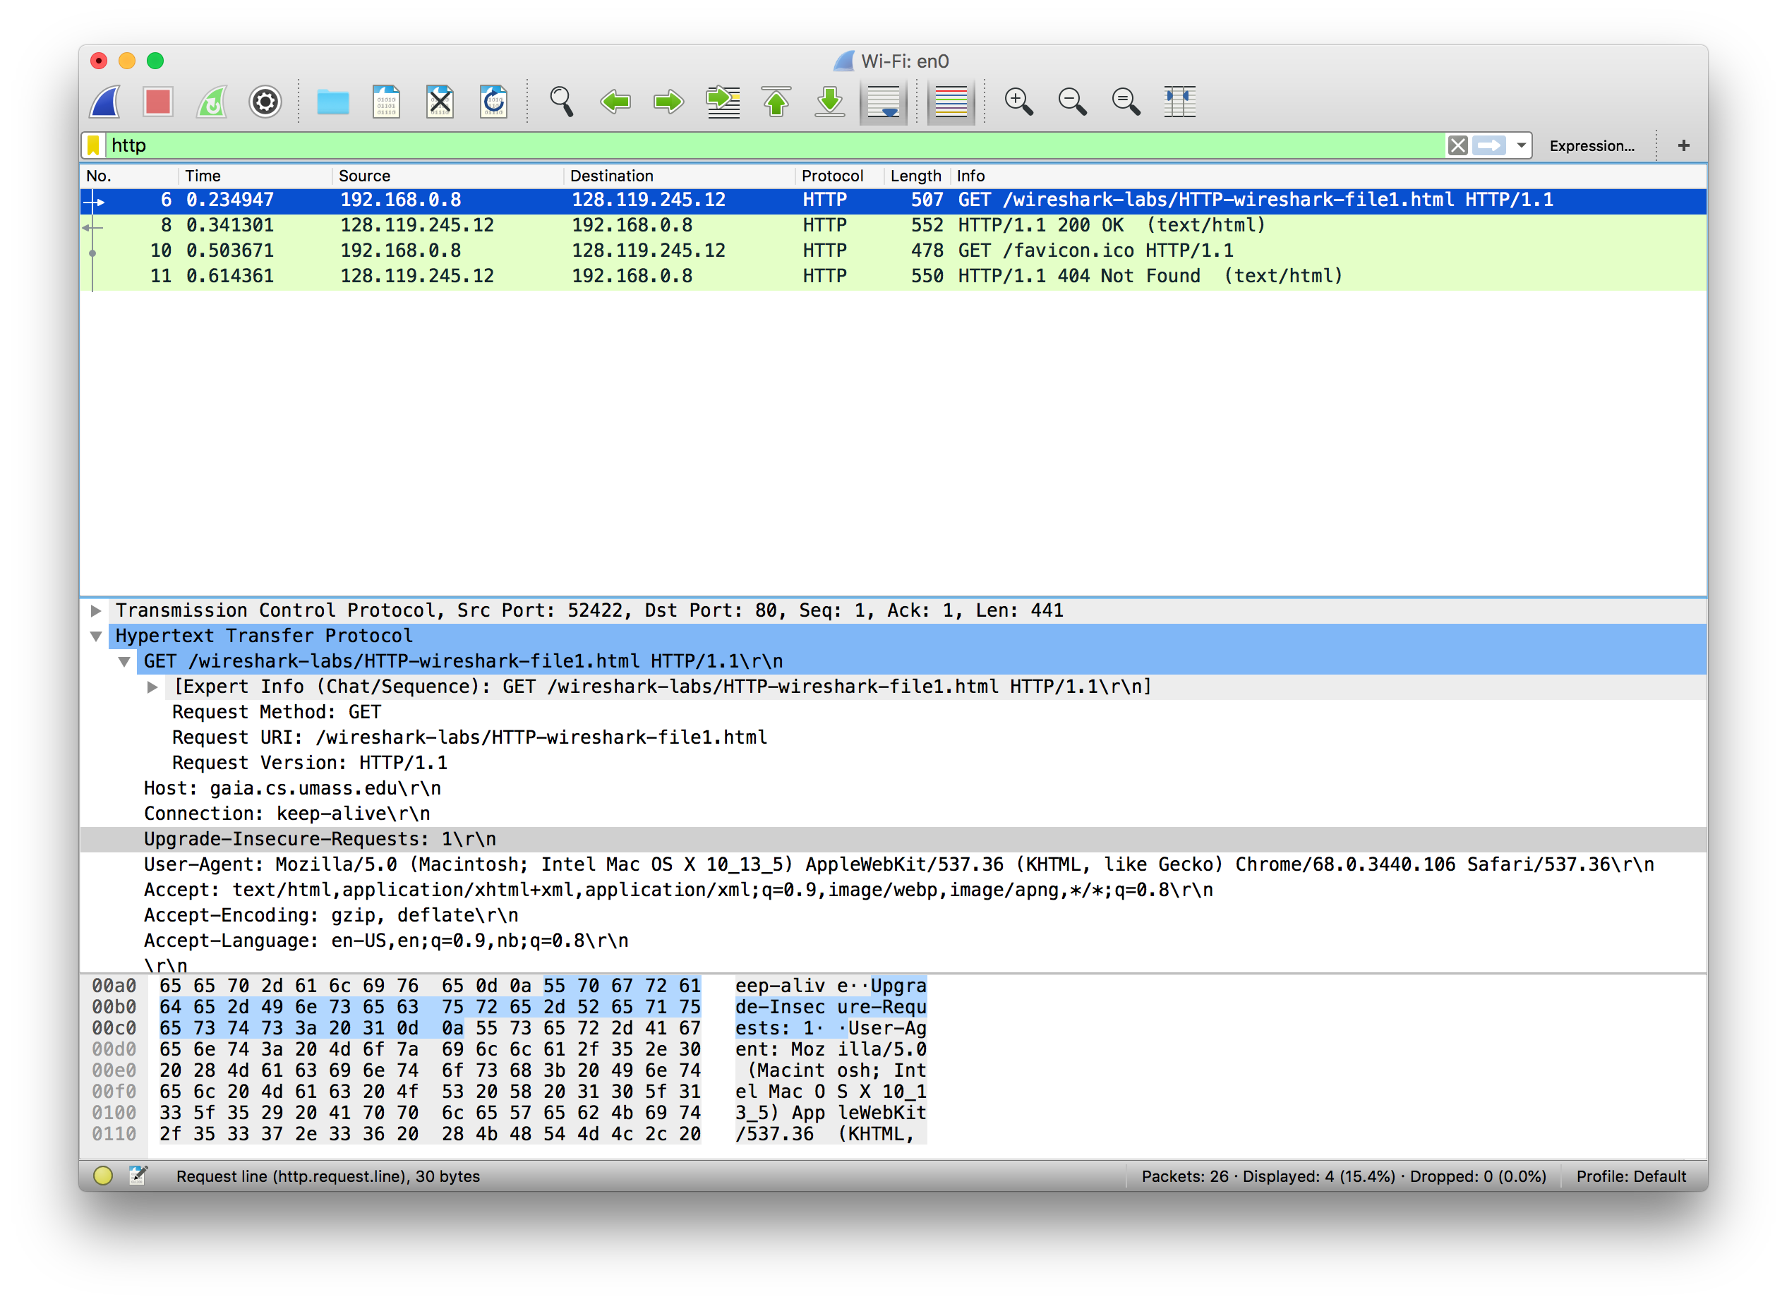

**c)** Status Code returned from the server to my browser: 200

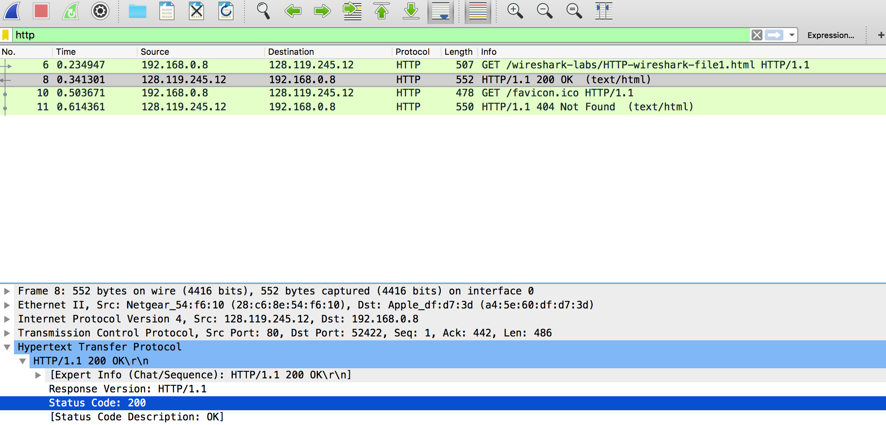

**d)** The HTML file was last-modified on: Sun, 23 Sep 2018 05:59:01 GMT

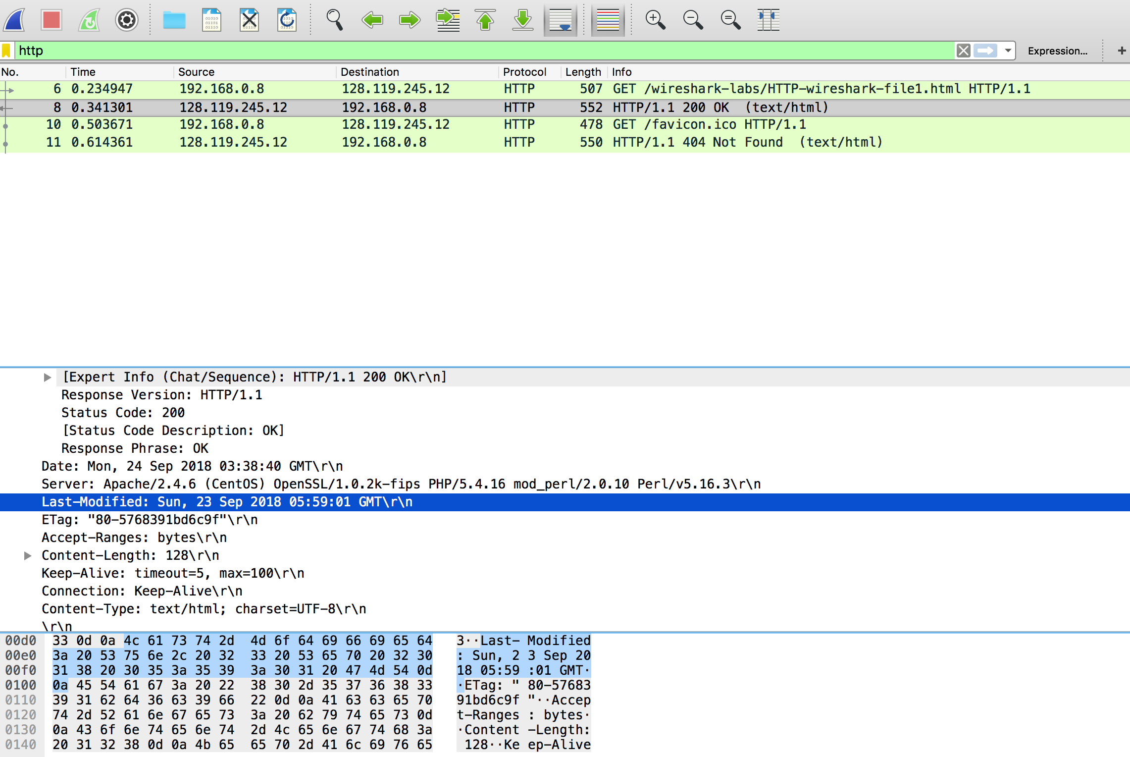

Part 3

**3.**

**a)** There is no IF-MODIFIED-SINCE header in the first request. (in first screenshot). The content is explicitly returned by the server in the first response as shown by the line-based text data in the response. (in second screenshot)

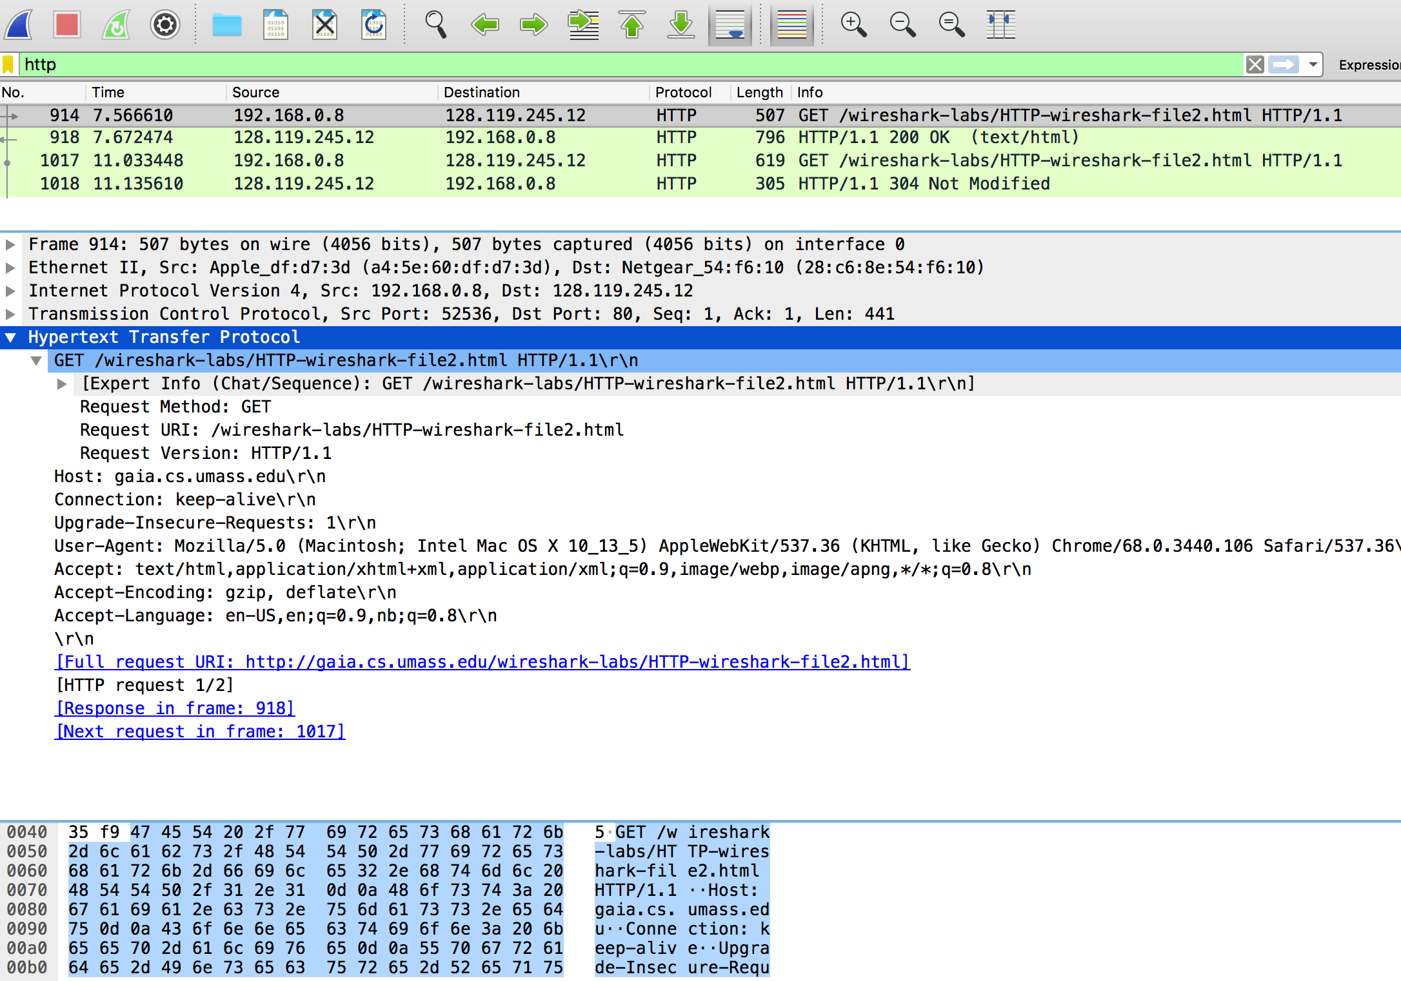

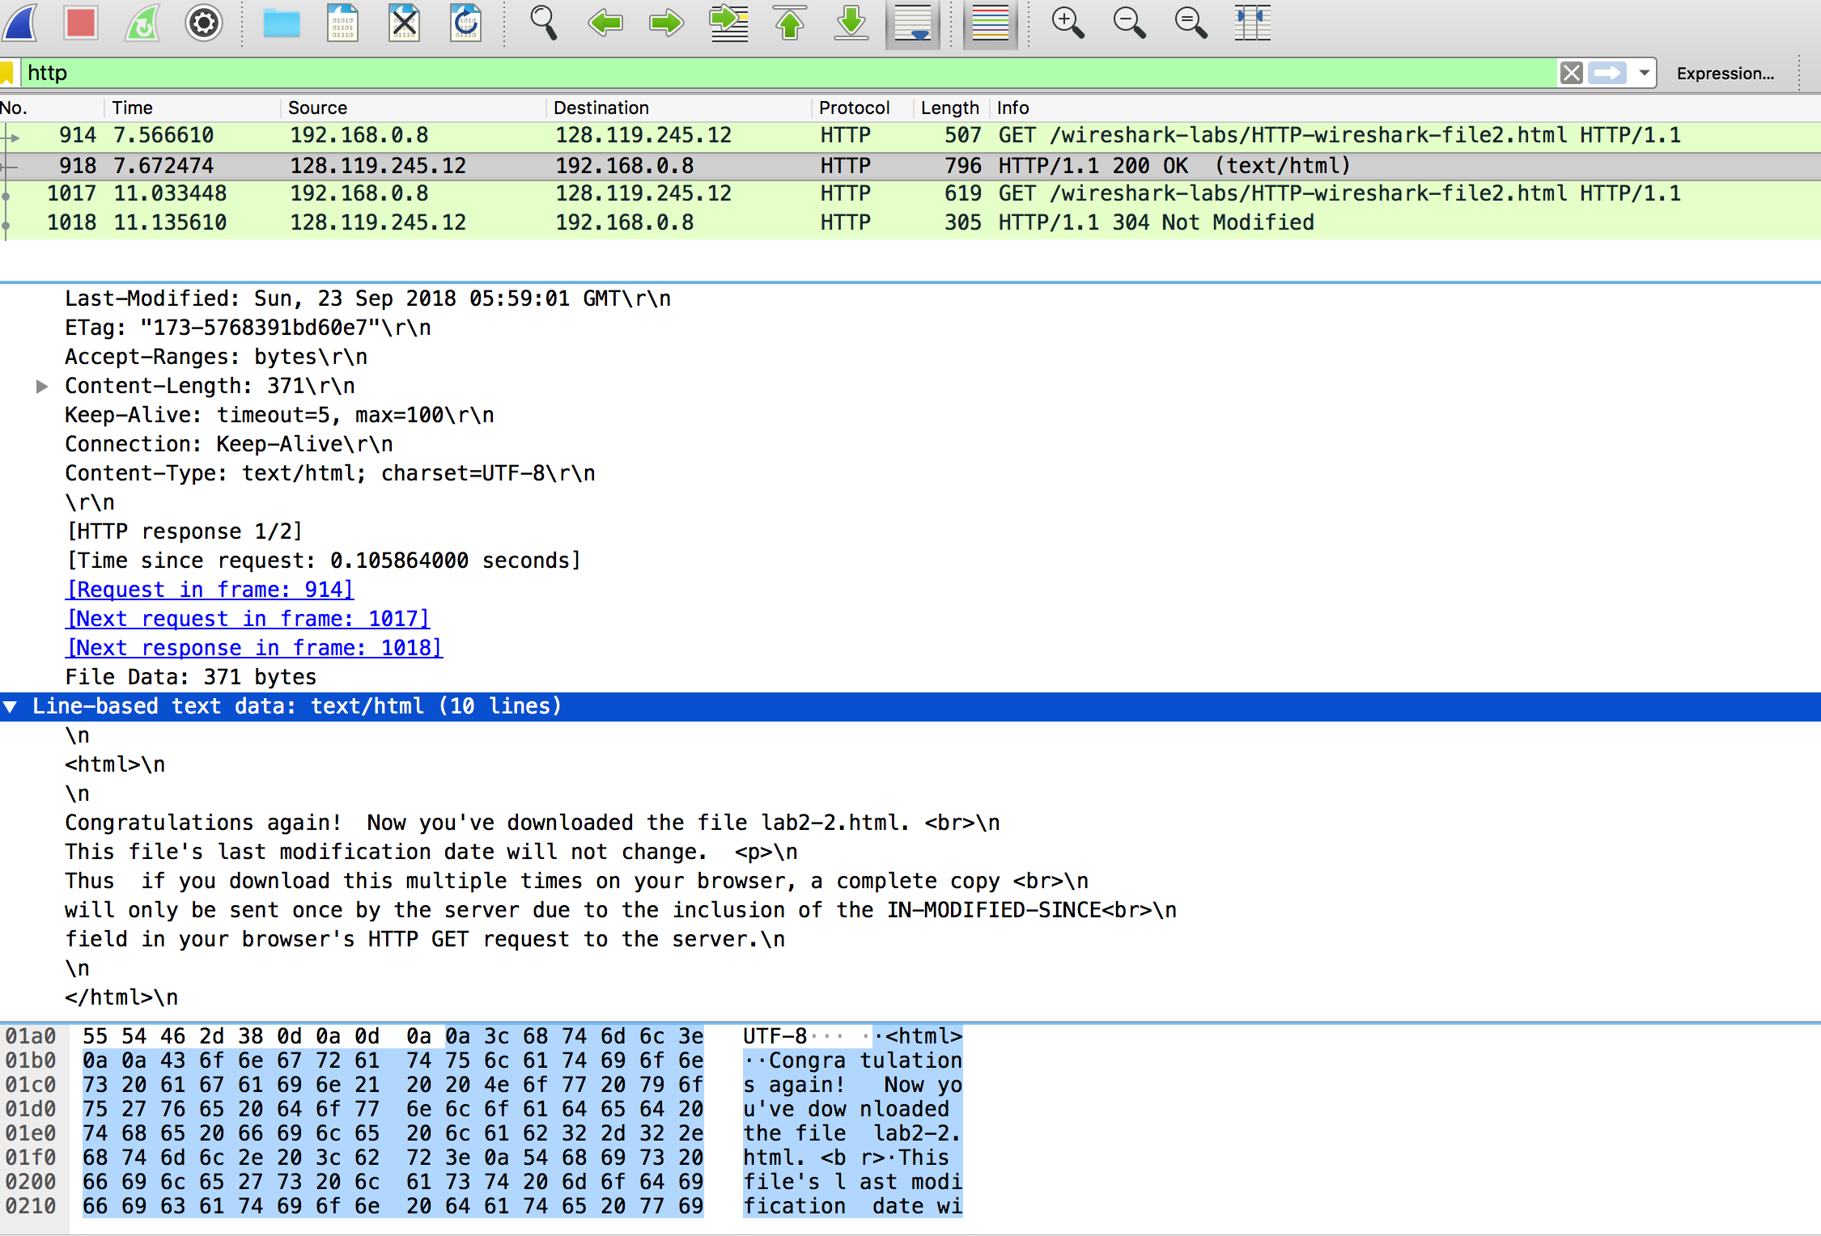

**b)** There is an IF-MODIFIED-SINCE header in the first request. It contains “Sun, 23 Sep 2018 05:59:01 GMT\r\n” (in first screenshot). The server responds with Status Code 304: Not Modified (in second screenshot and line below selection). This is because there has been no change to the data since the last request not long ago. There is no need to respond with all of the data. 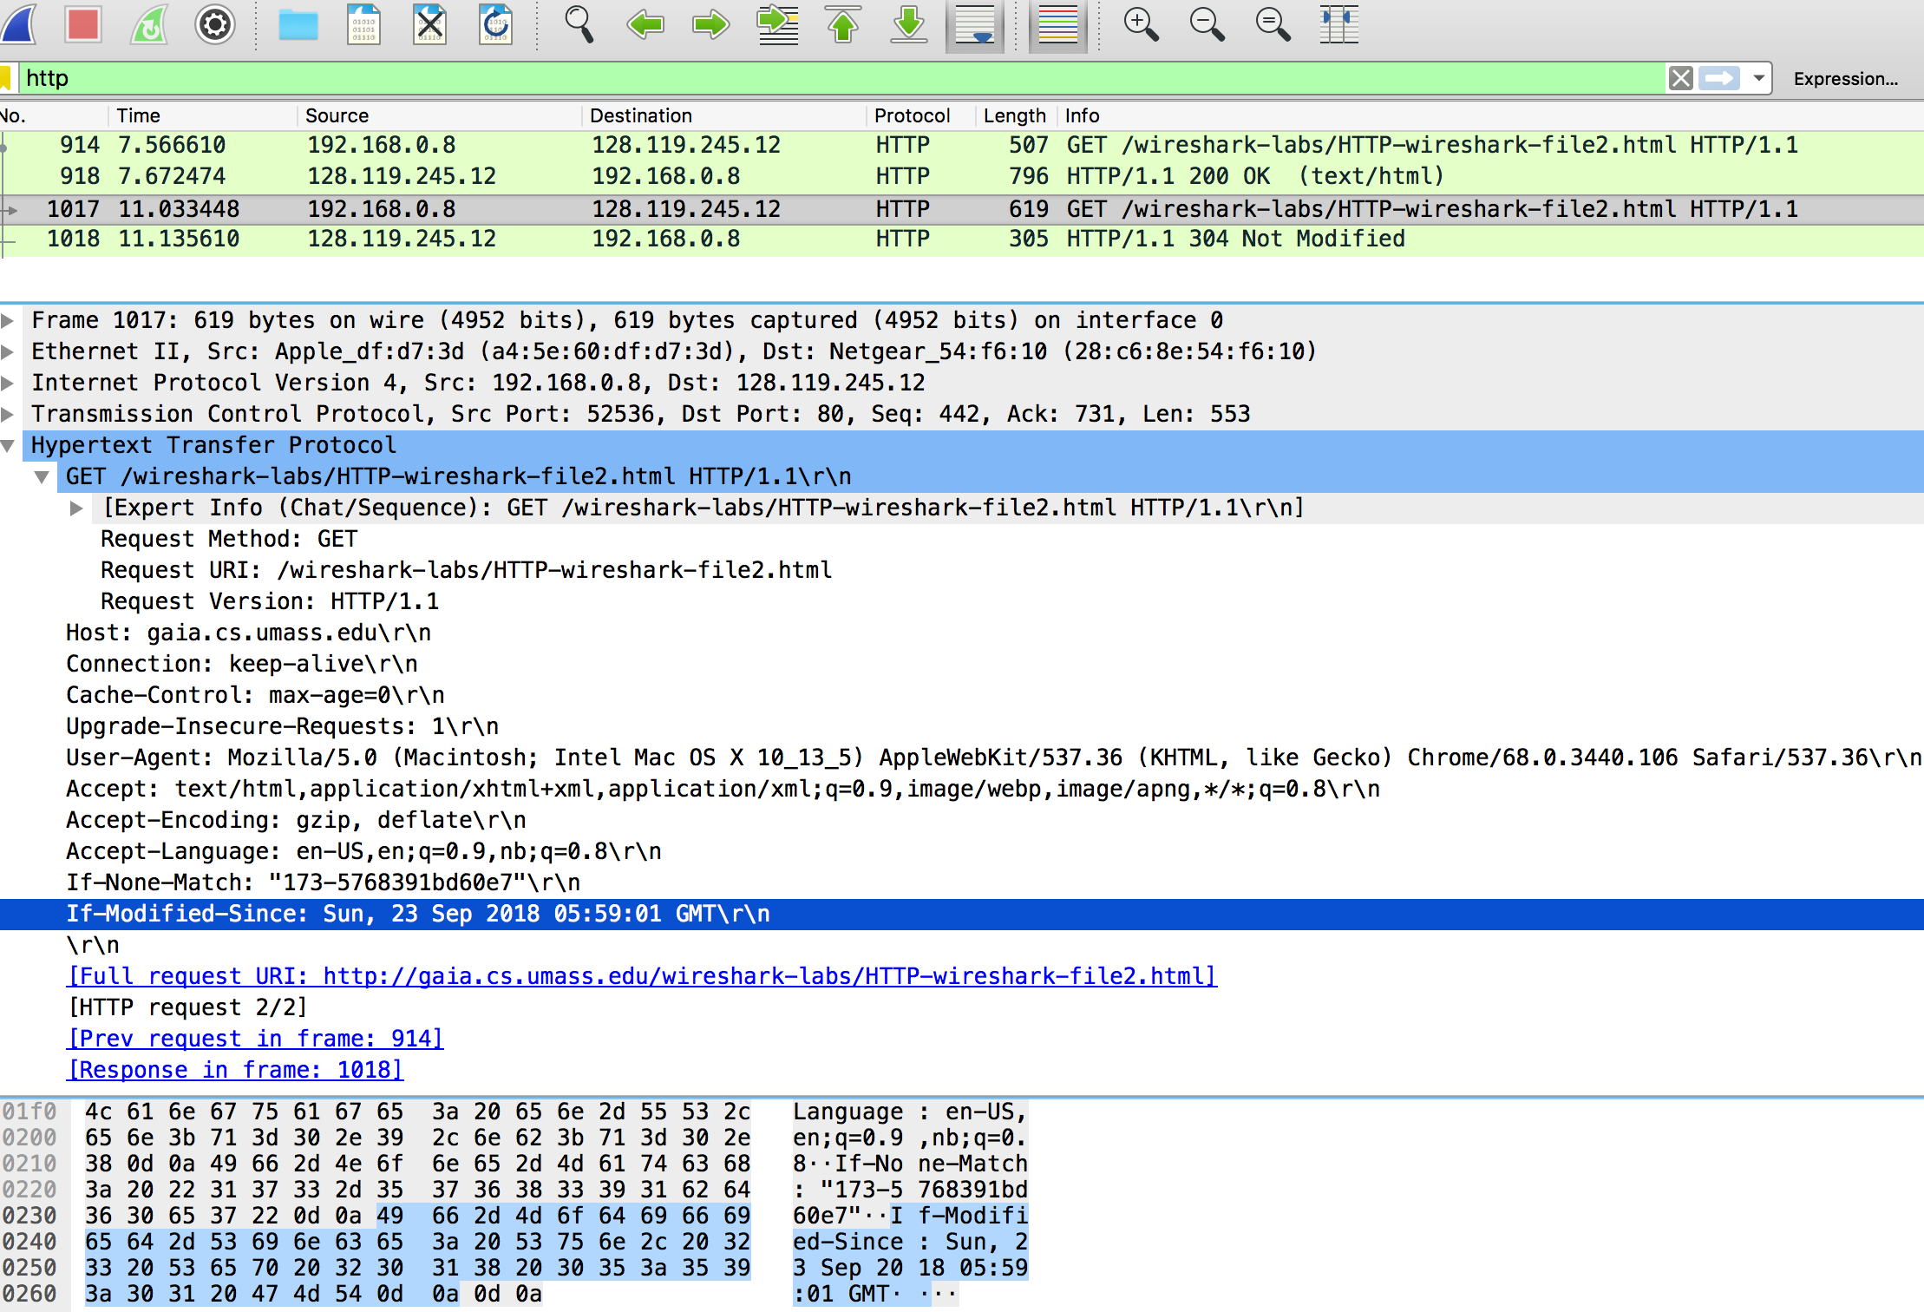

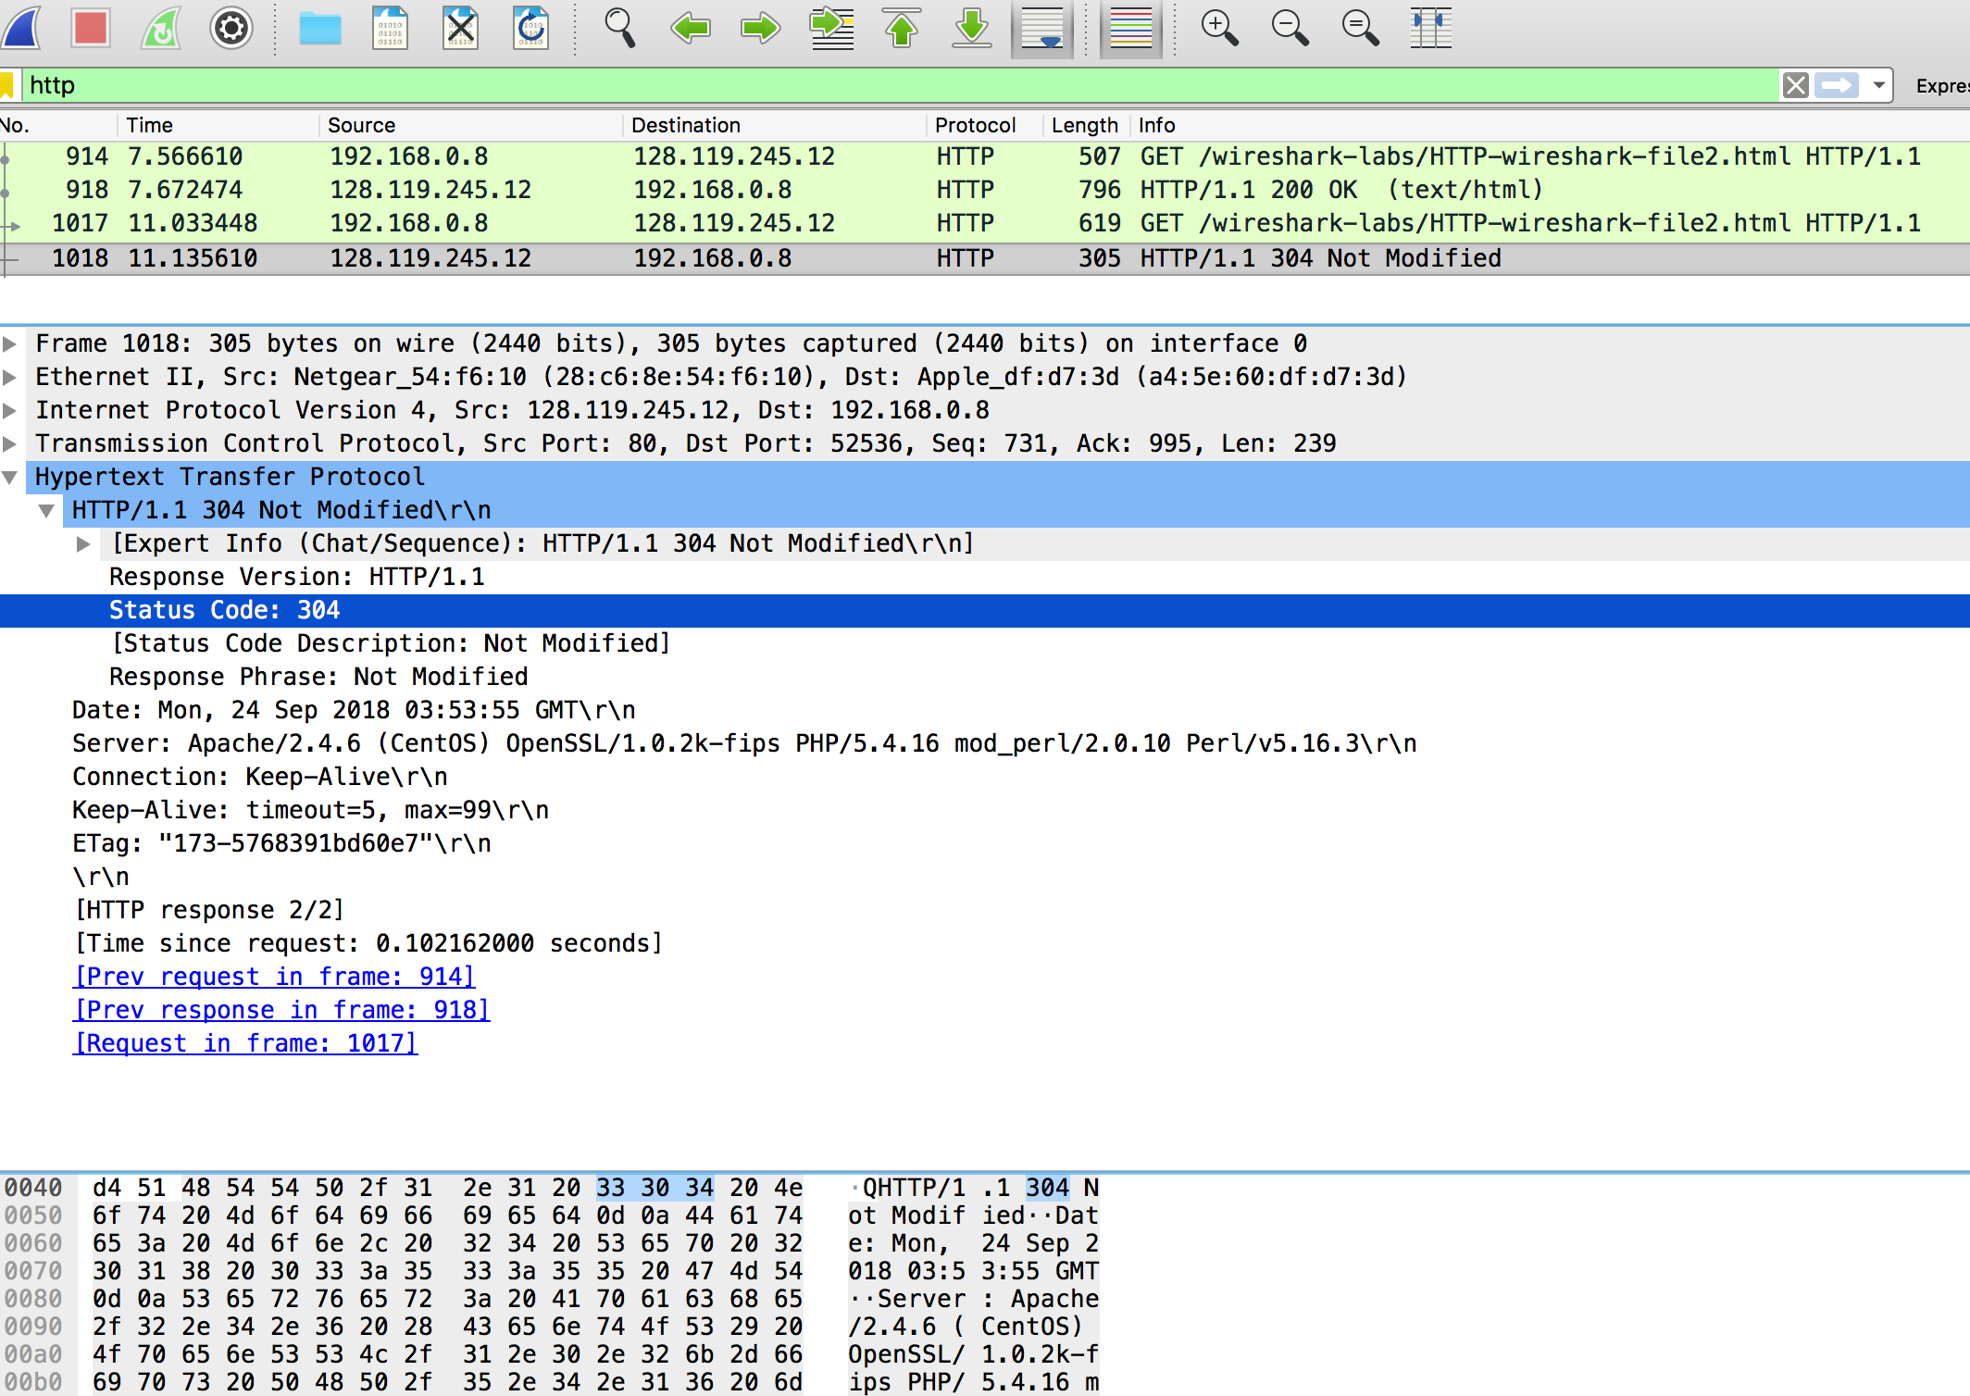

Part 4

**4.**

**a)** The IP Addresses given was: 216.58.193.174. This was achieved with command: `nslookup google.com`.

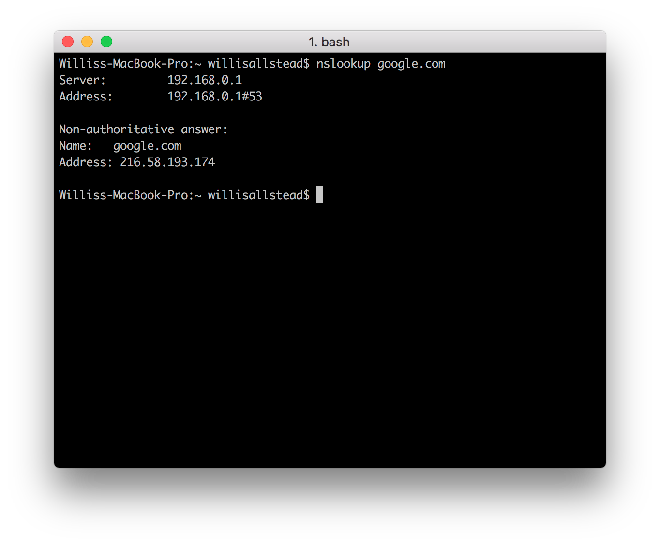

**b)** As you can see above, there was no server obviously designated as the one giving the answer. But, you can see that it is a non-authoritative answer. It seems like 192.168.0.1 is the server giving the response.

**c)** I found that the response in wireshark listed the A-record (as was expected by not specifying the type), a TTL of 226, and an address of 172.217.4.14 (which was the address of the server it was pointing to this time).

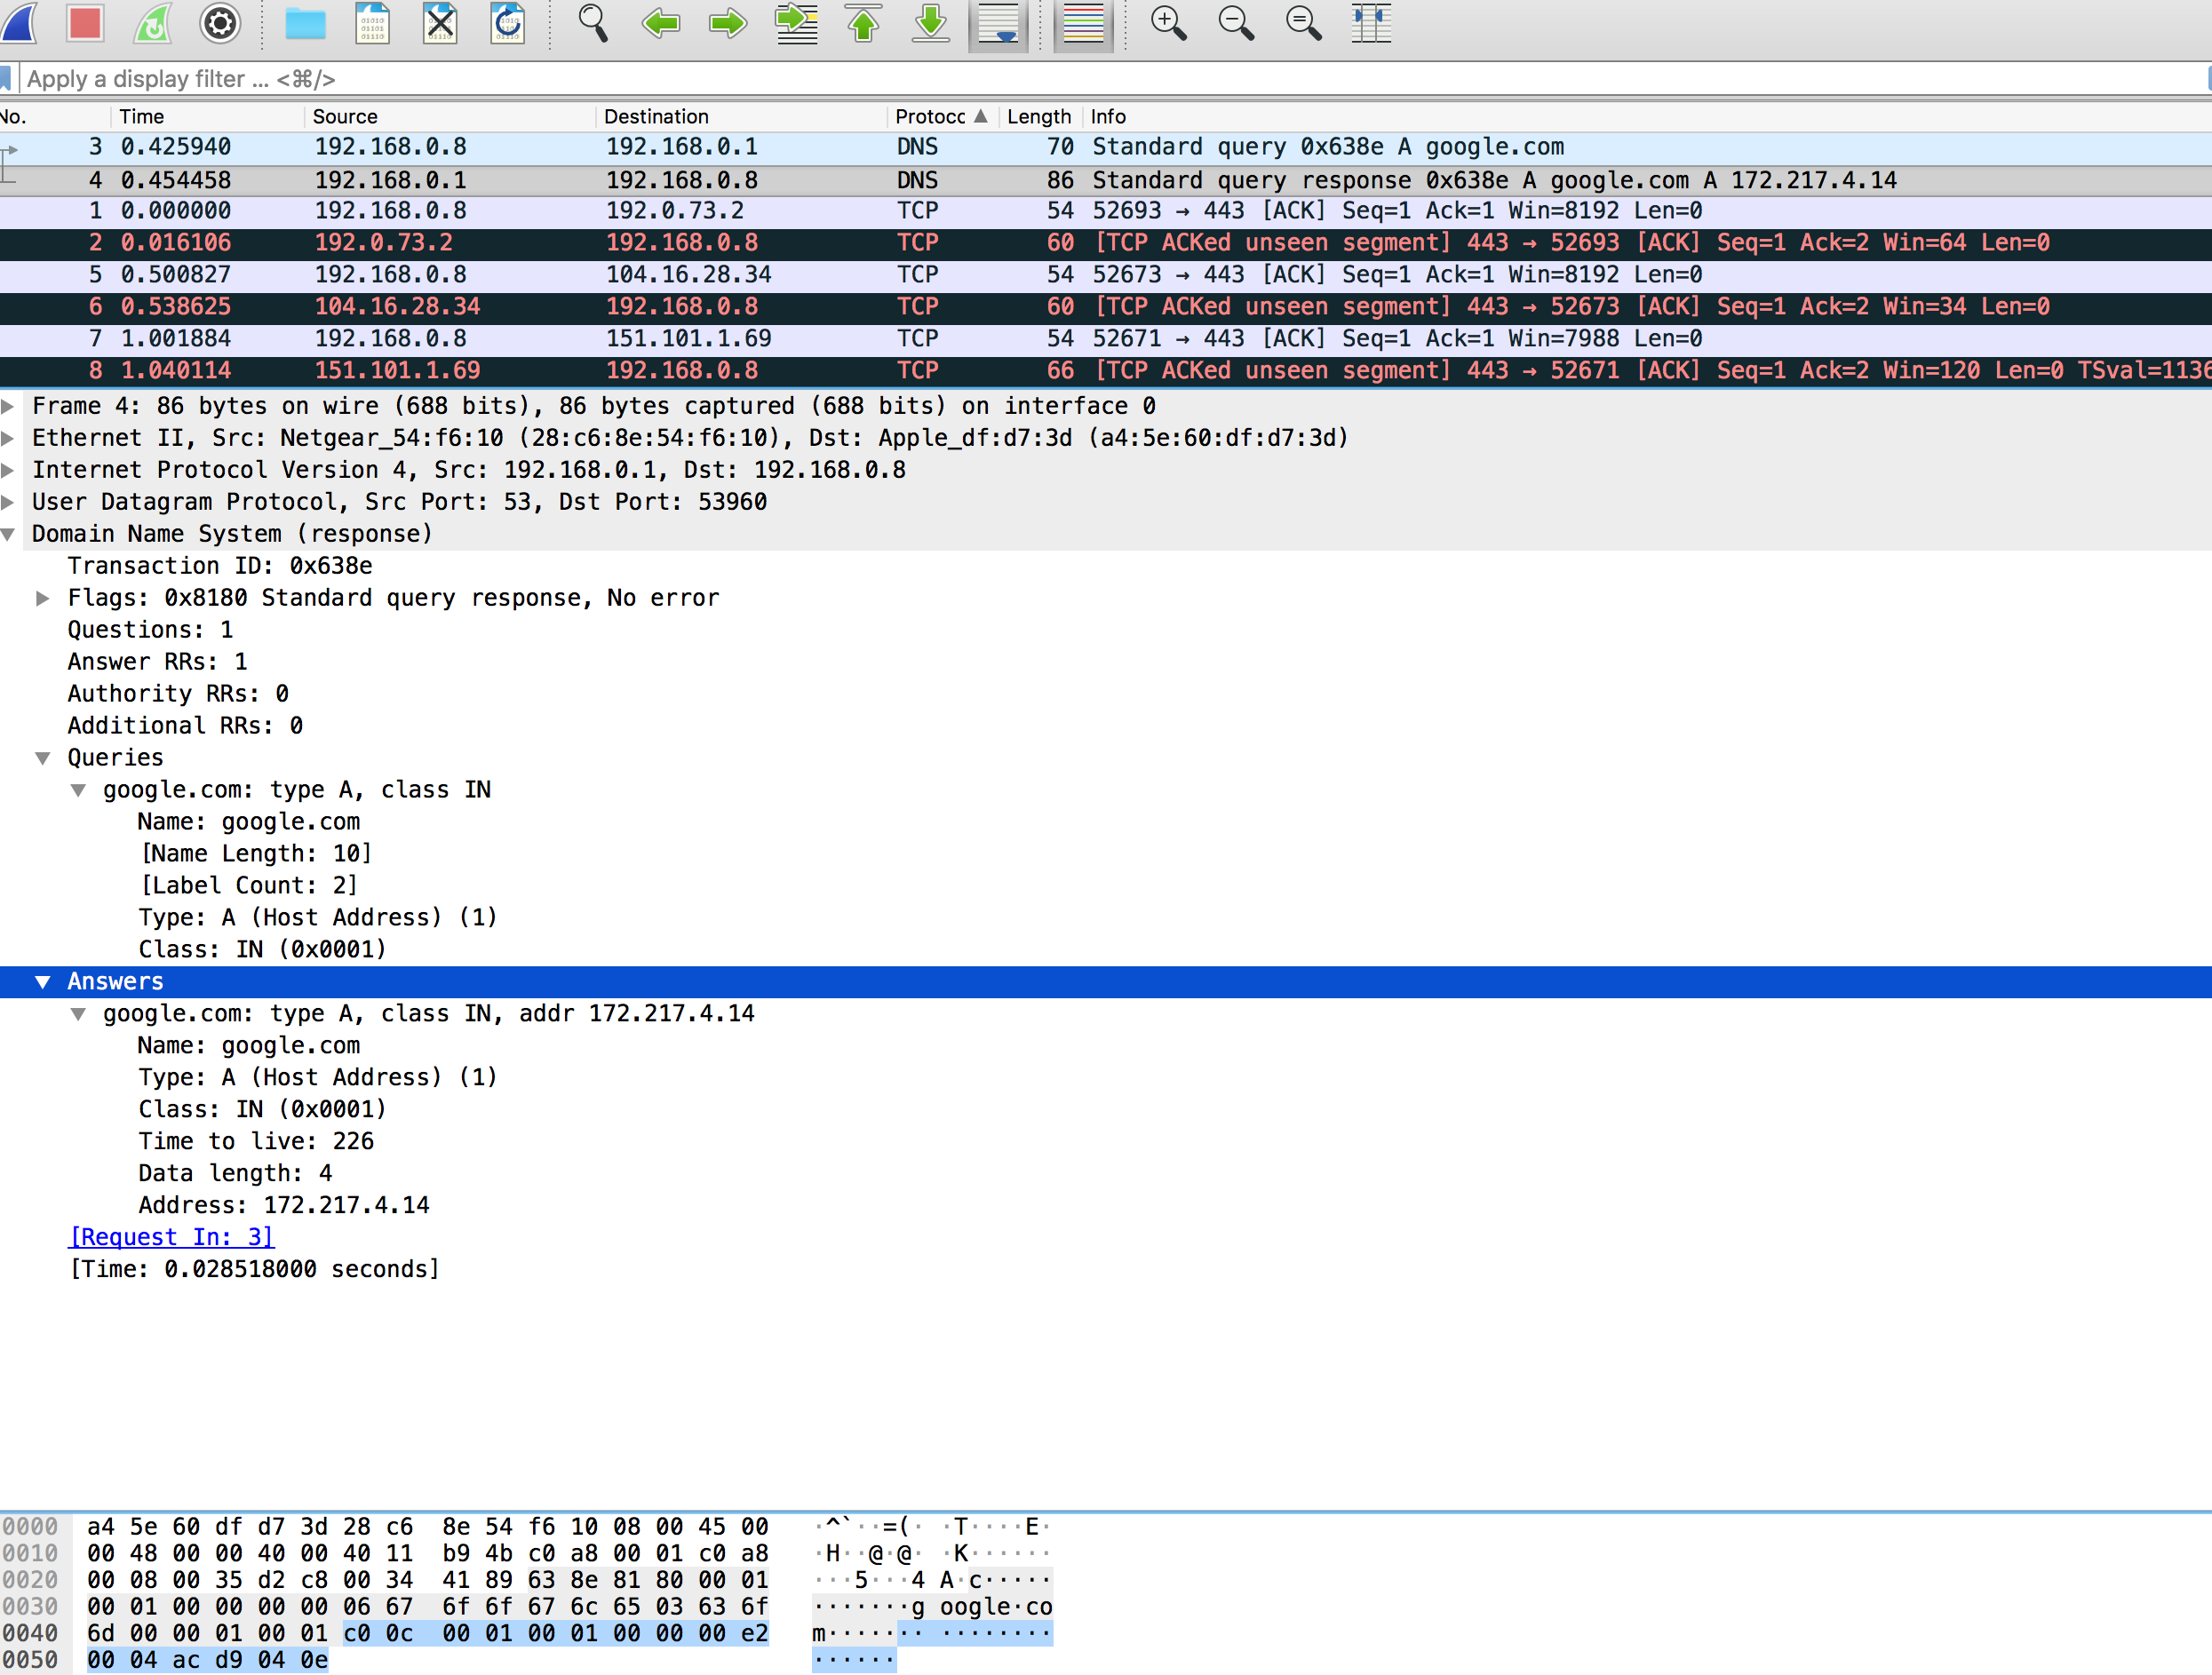

**d)** I ran the command shown in the screenshot below and got the following results. In wireshark I received 4 answers of type NS for my query if google.com. Each contained a name server, like ns1.google.com, ns2.google.com, etc.

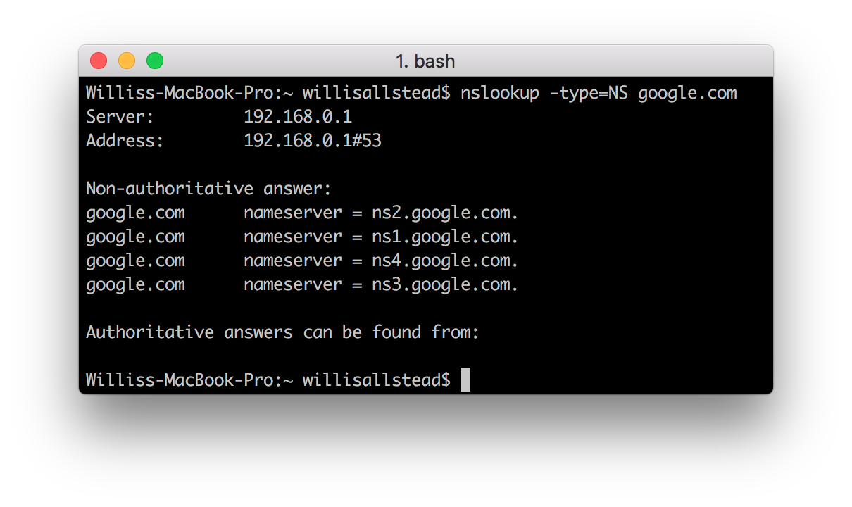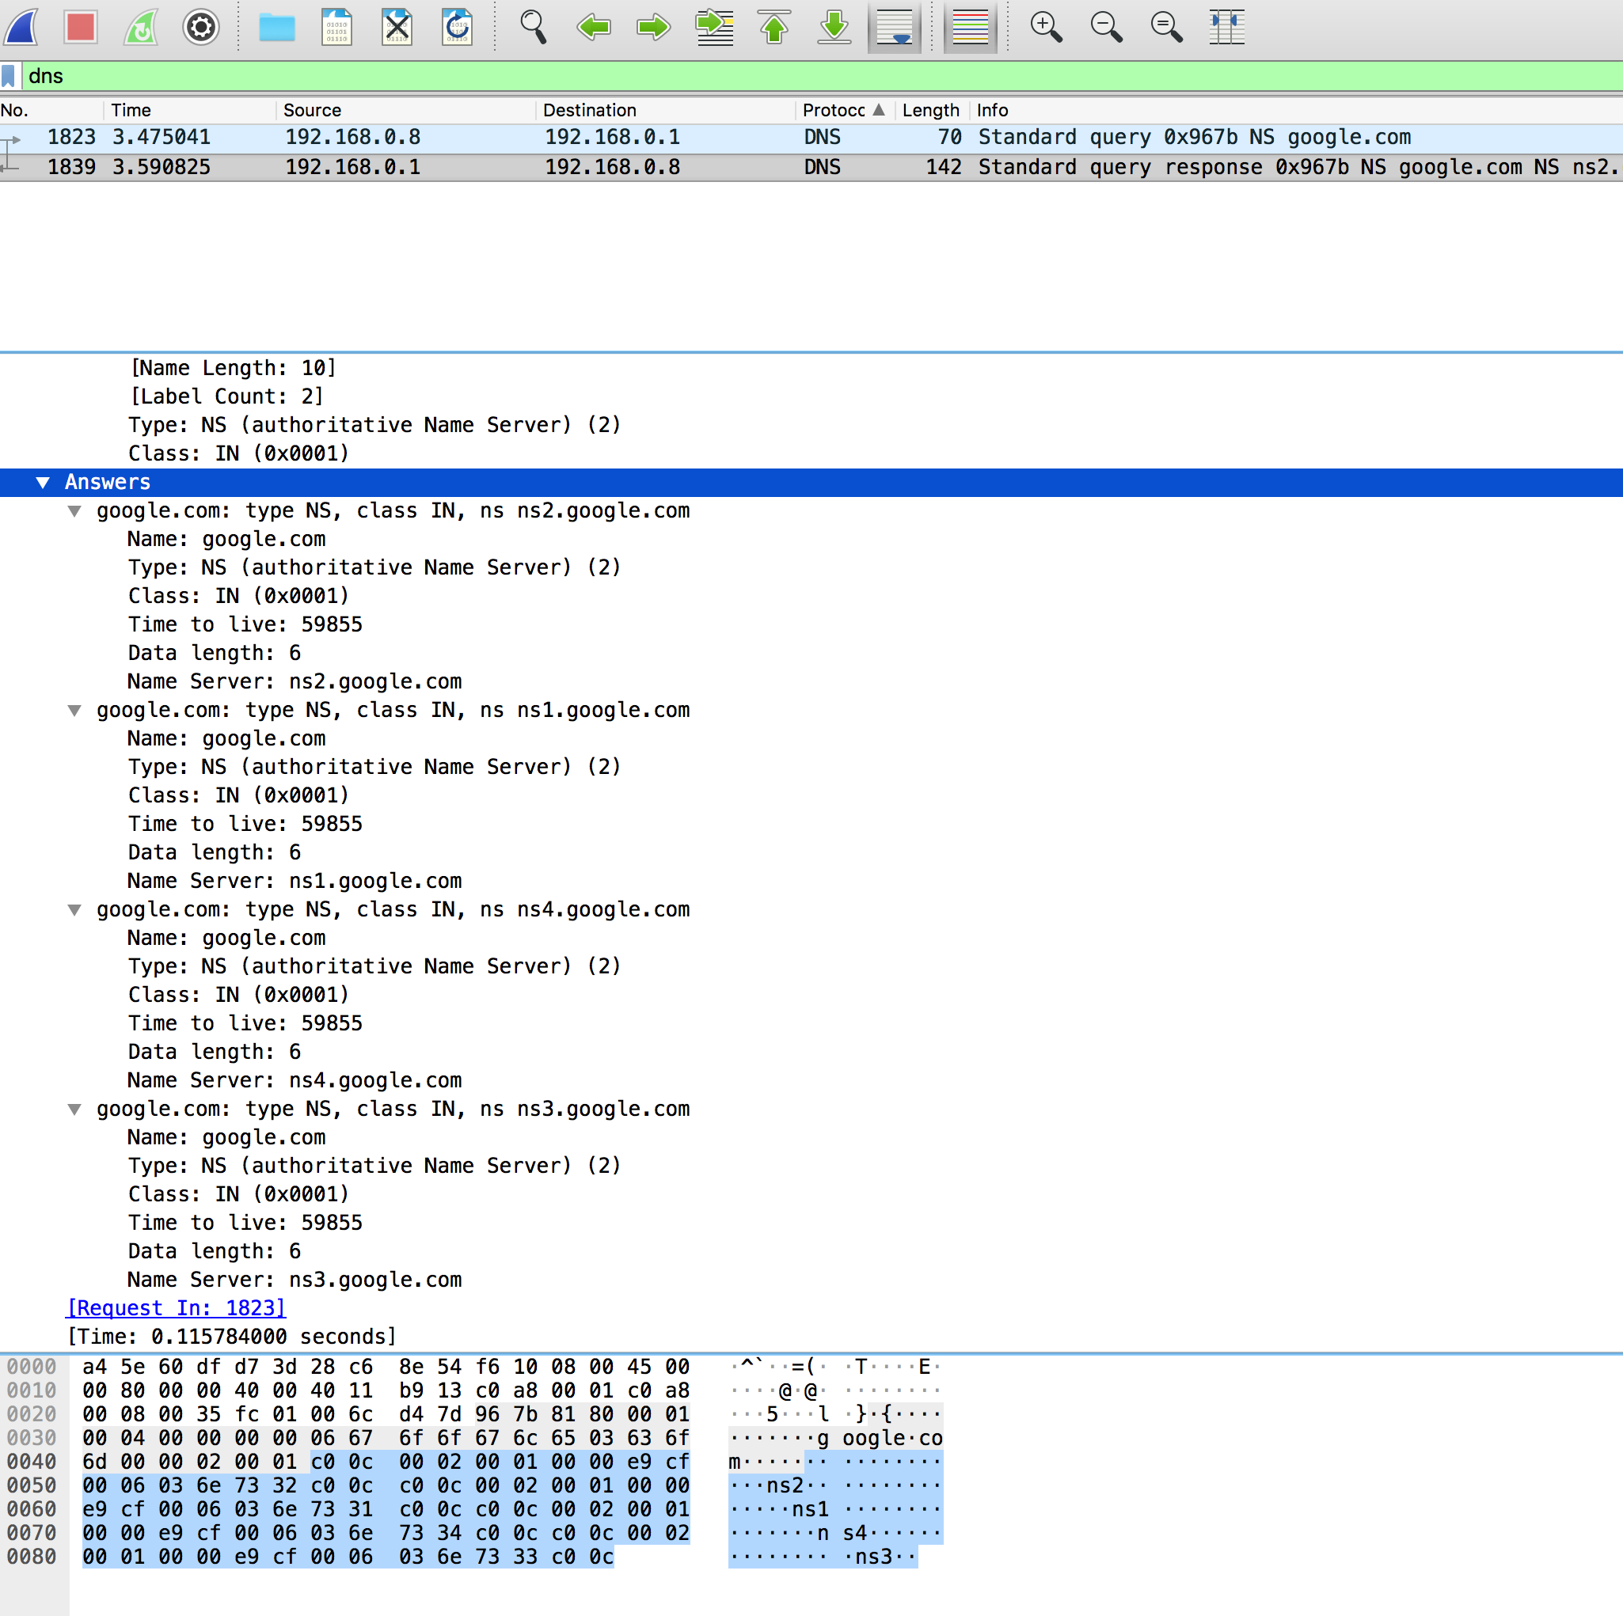

**e)** I ran the command shown in the screenshot below using ns1.google.com instead of the default nameserver. You can see that in the wireshark response the answer was of type A but there was no mention in either nslookup or wireshark of the response being non-authoritative.

